*Term Project*

*Instructor: Faisal Khan*

|  |  |  |
| --- | --- | --- |
| *Name* | *Student ID* | *Group#* |
| *Rahul Kathroju* | *C0911587* |  |
| *Ranish Shrestha* | *C0916260* |  |
| *Utsav Bajracharya* | *C0913555* |  |
|  |  |  |
|  |  |  |

1-Use Documentation Comments where needed and use Javadoc to create HTML files for documentation.

2-In your project src folder add this word document with all your group members names and paste the screen shots of your output after each question.

2-Right Click on your Project Folder in Eclipse, Copy Option is available. Create a copy of the Project and upload the zipped folder using Moodle.

Create java desktop application with CRUD functionality using Java Fx Api or Scanner Class. You should create an application for a Doctor’s Office. You have to maintain the record of patients using this application. You will be using a Patient class with the fields like Patientid,Name,Contact,Region,Disease,VisitDate .You have to follow these steps for this application.

a-Create a database named PatientRecords. 10

* Database created in MySQL Workbench

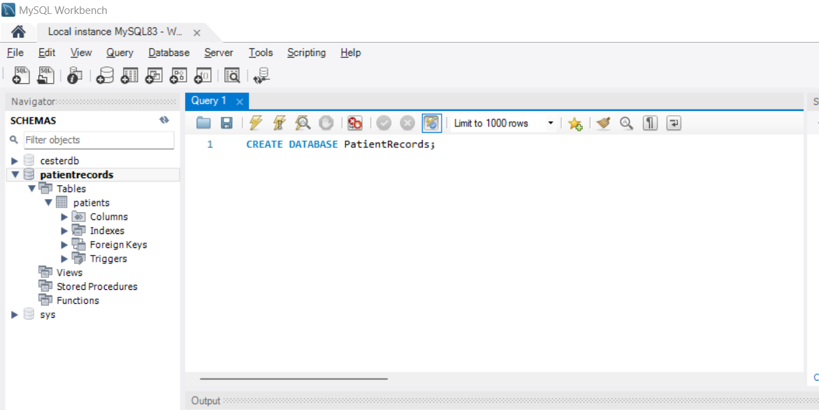

b-Create table named Patients in the database. 10

* Table created and named it as patients

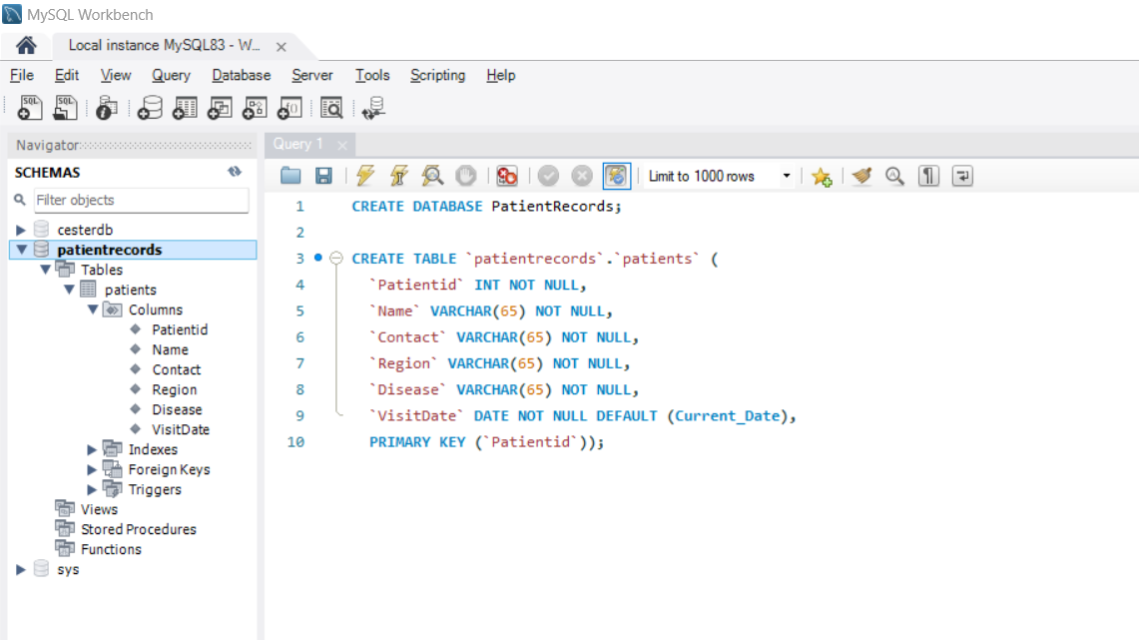

c-Insert 5 or 6 Patient Records in the database 10

* Records inserted into the patient's table

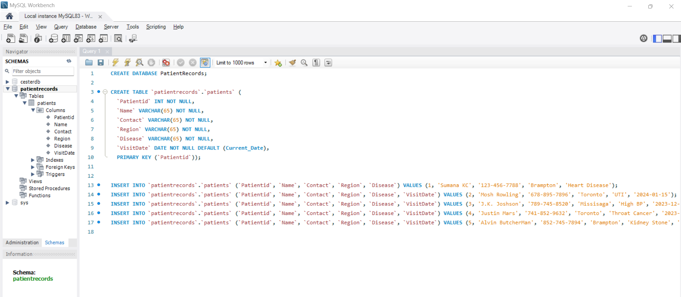

d-Add Jar file for your database to the lib Folder 10

* Jar file added to the lib

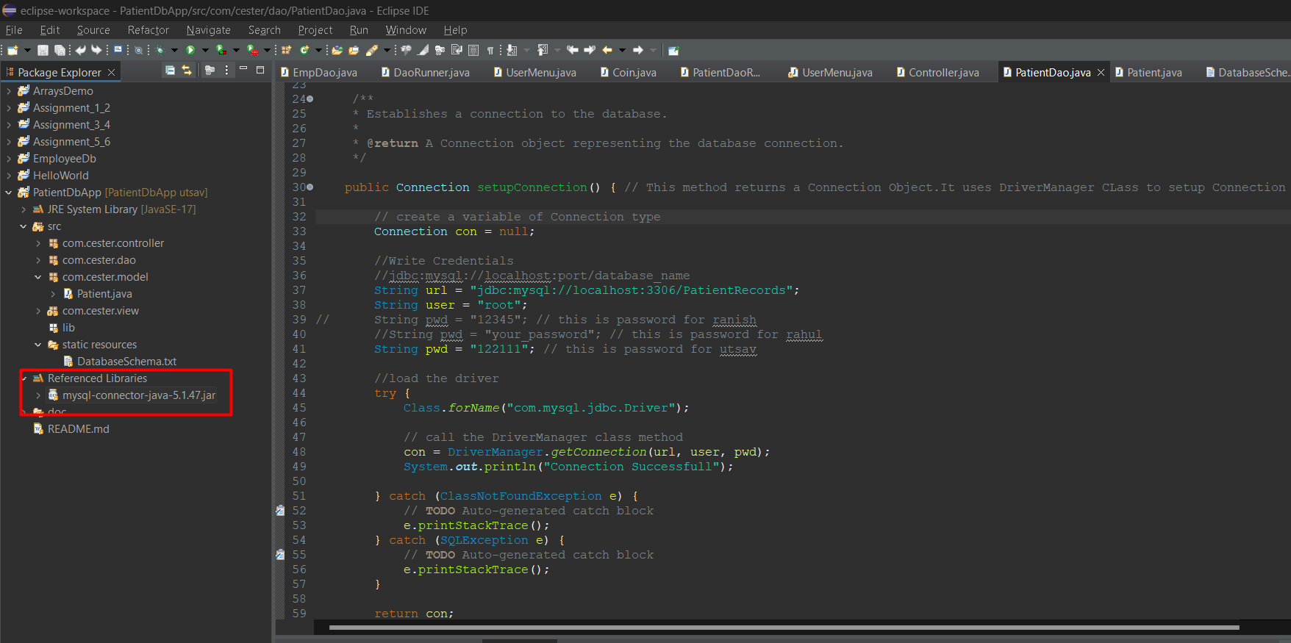

e-Create one Java class as a Model class. 10

* Java class named Patient as a Model class  
    
  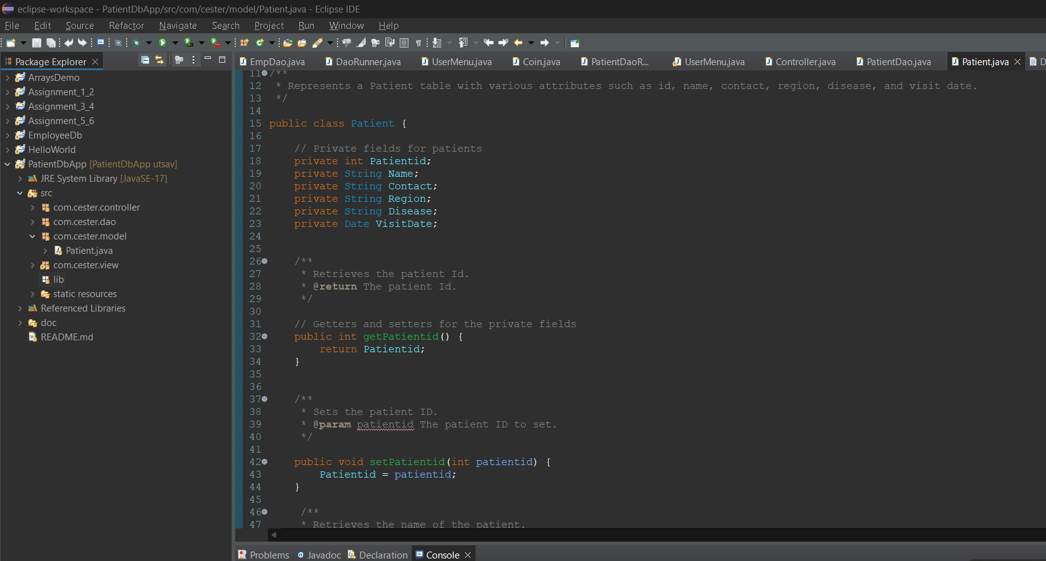

f-Create a separate DAO class for database connectivity.10

* Setup connection with database in DAO class

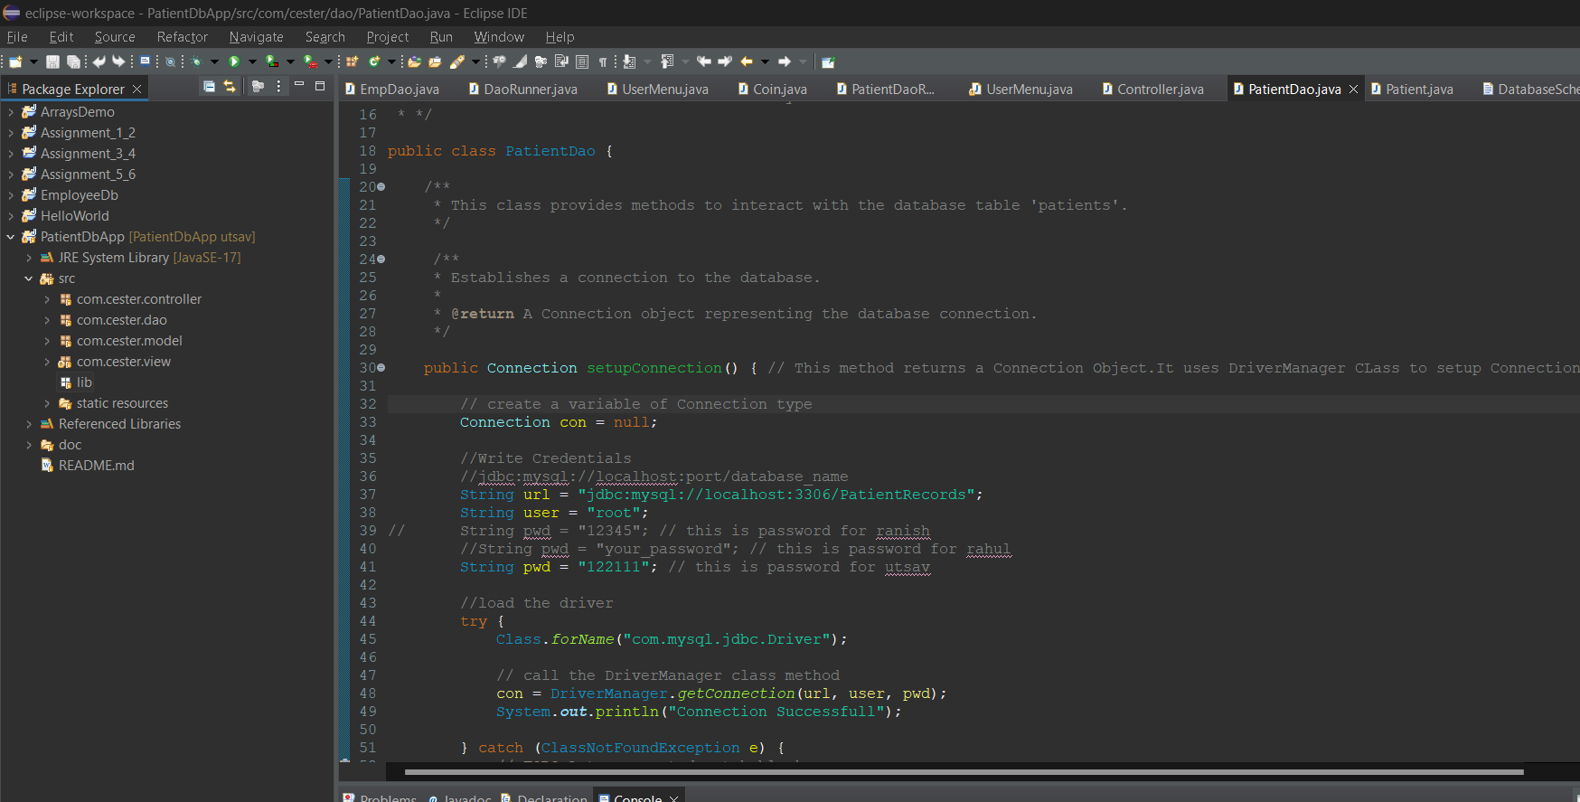

g-Create separate methods for connection and all crud operations. 20

* Controller java class with all the methods of display, insert, find, update, delete records

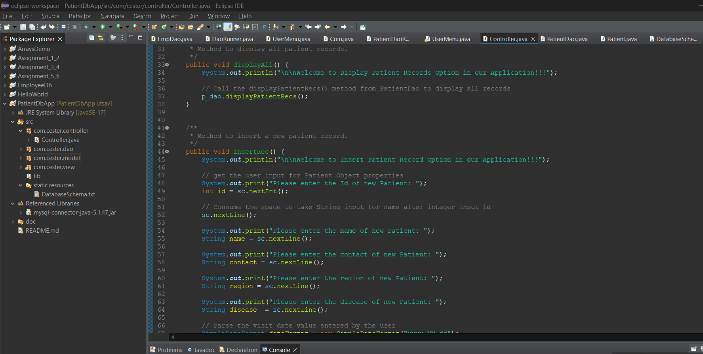

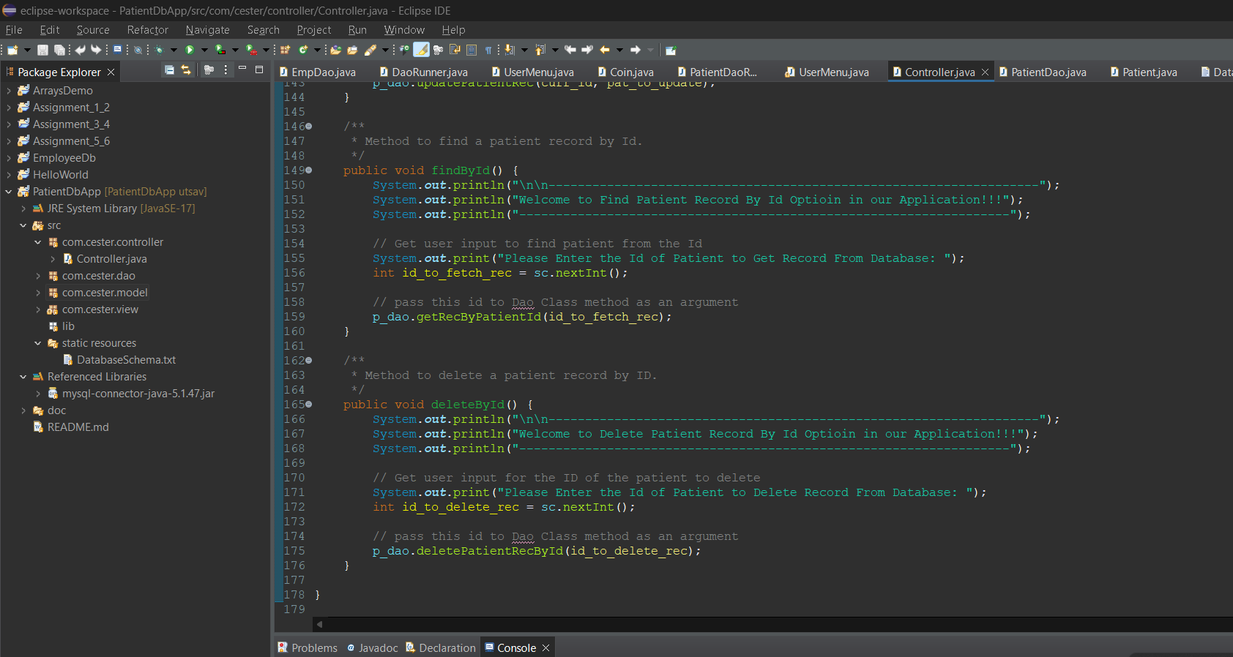

h-Create a third separate java class and call these methods in this class to display data on console or Display using Java Fx Api . 20

* View java class called UserMenu to call methods and display data on console

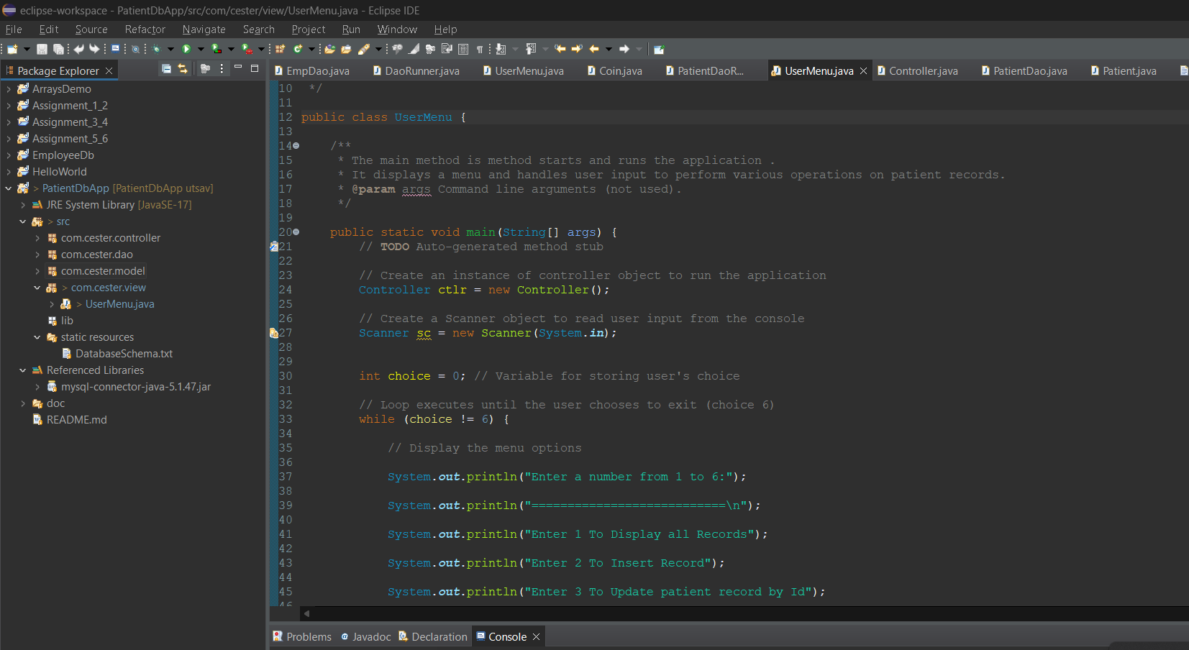

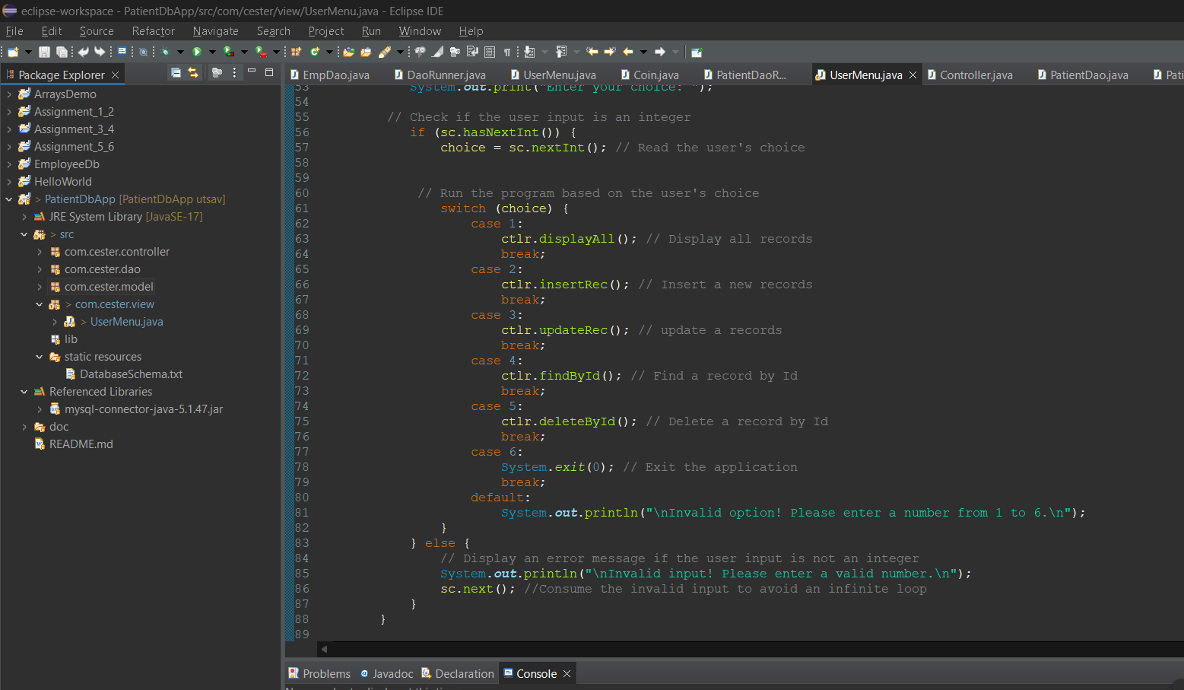

Output:  
  
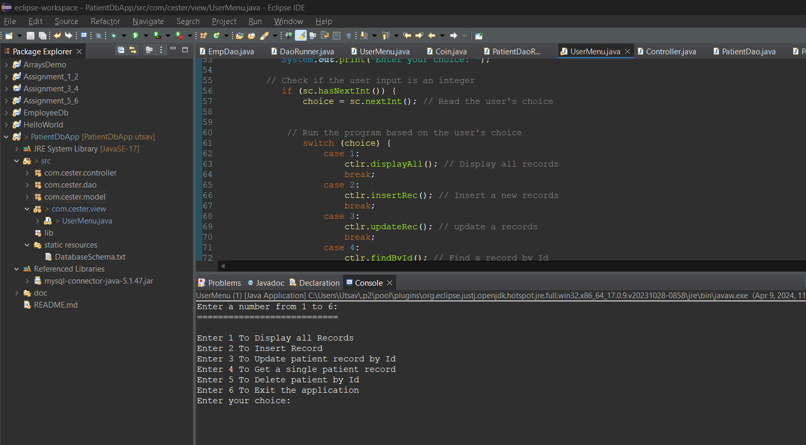

* Display all records

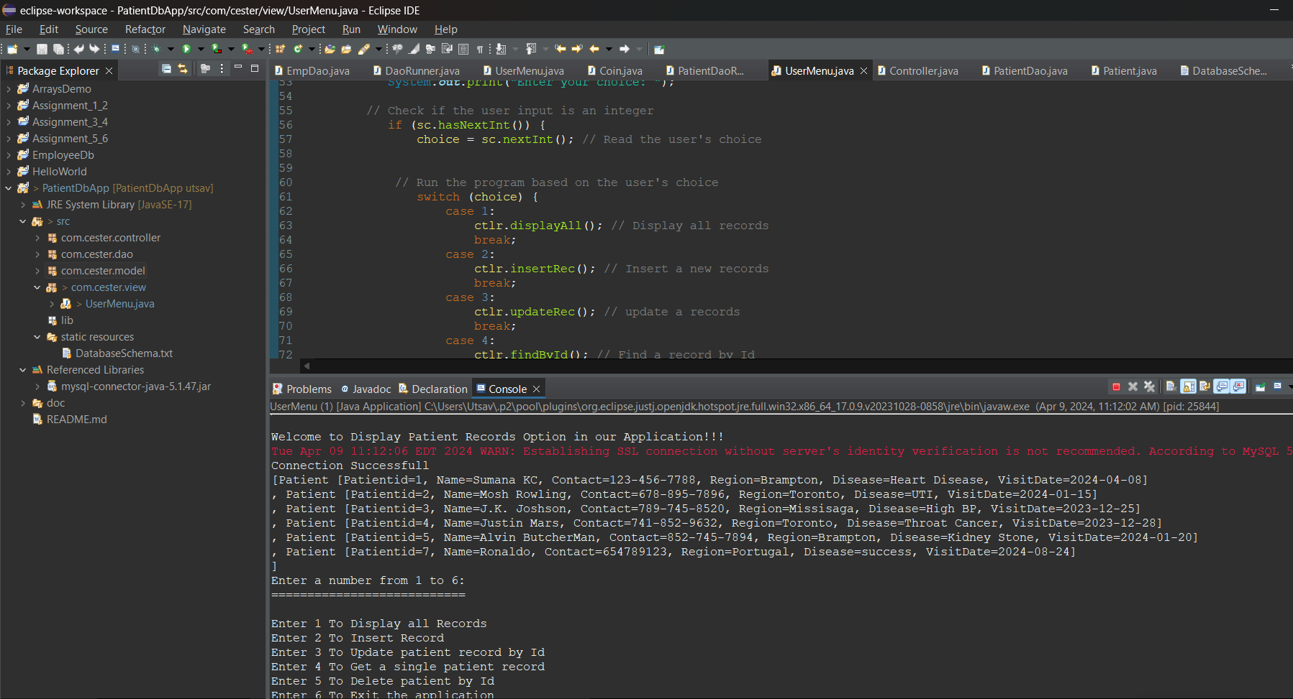

* Insert Records

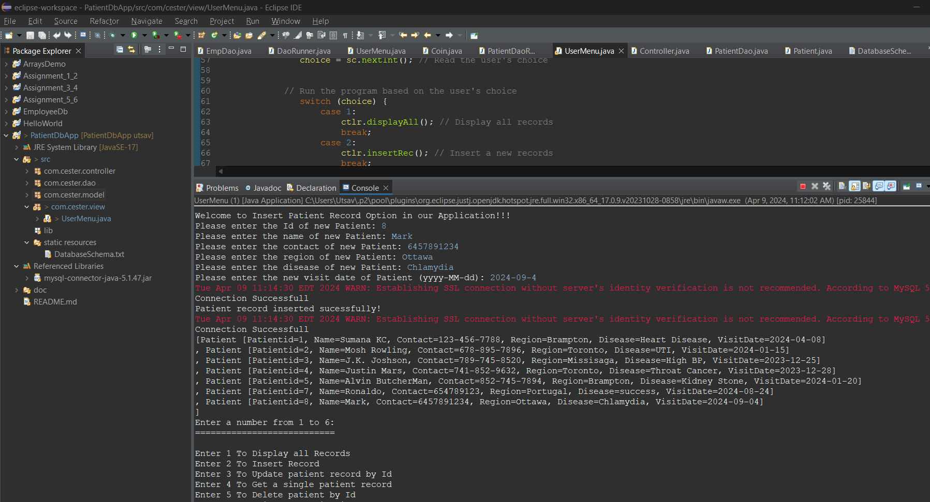

* Update record

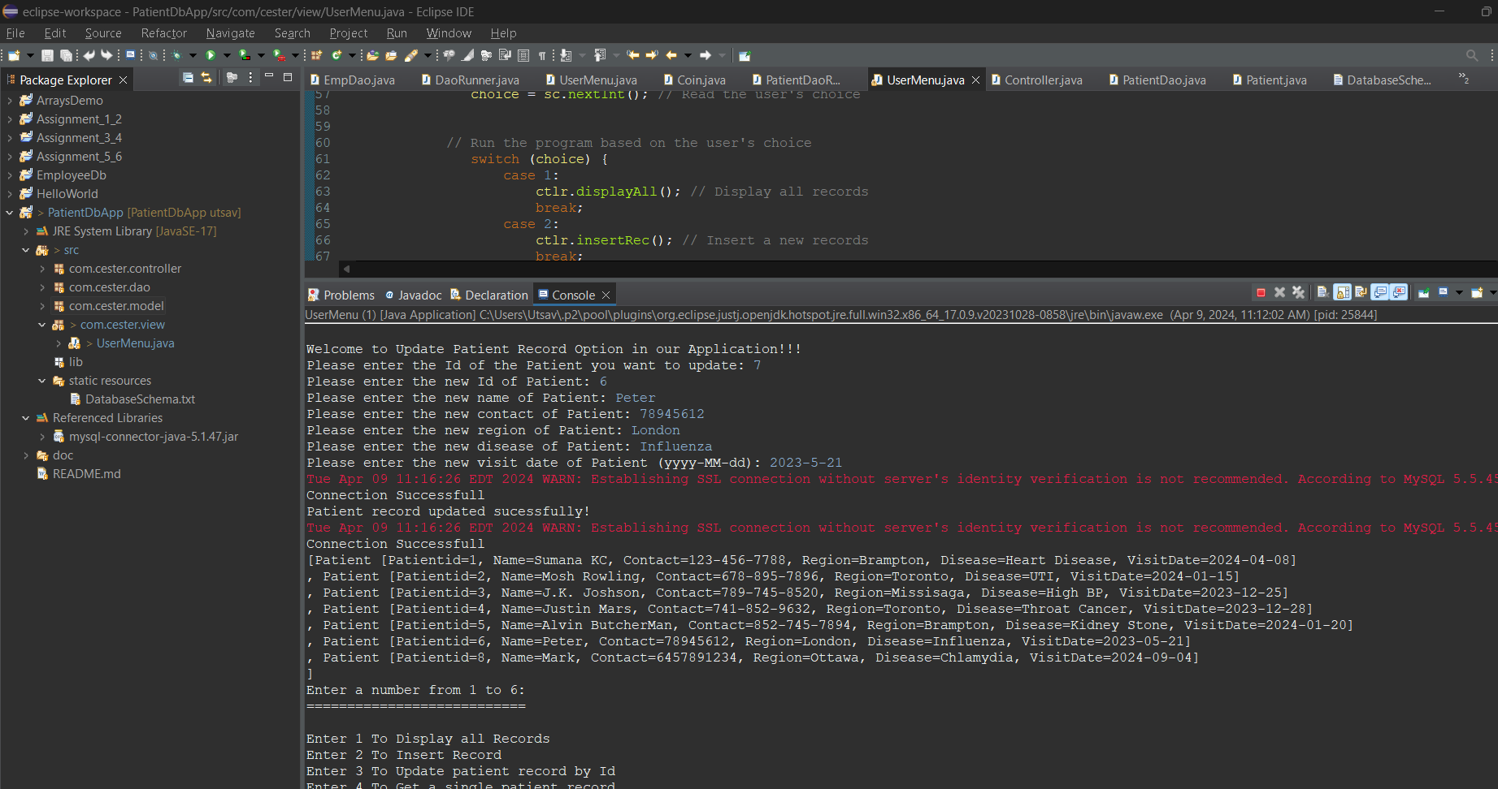

* Find record by Id

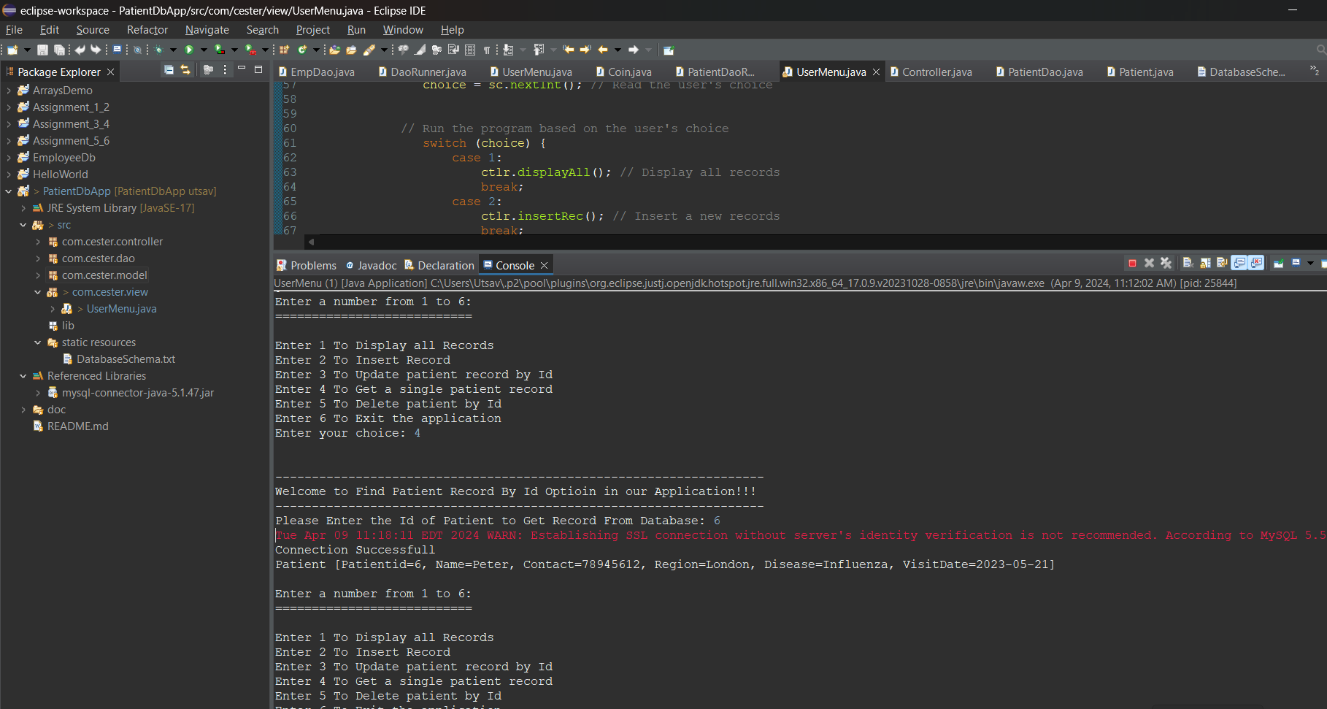

* Delete record

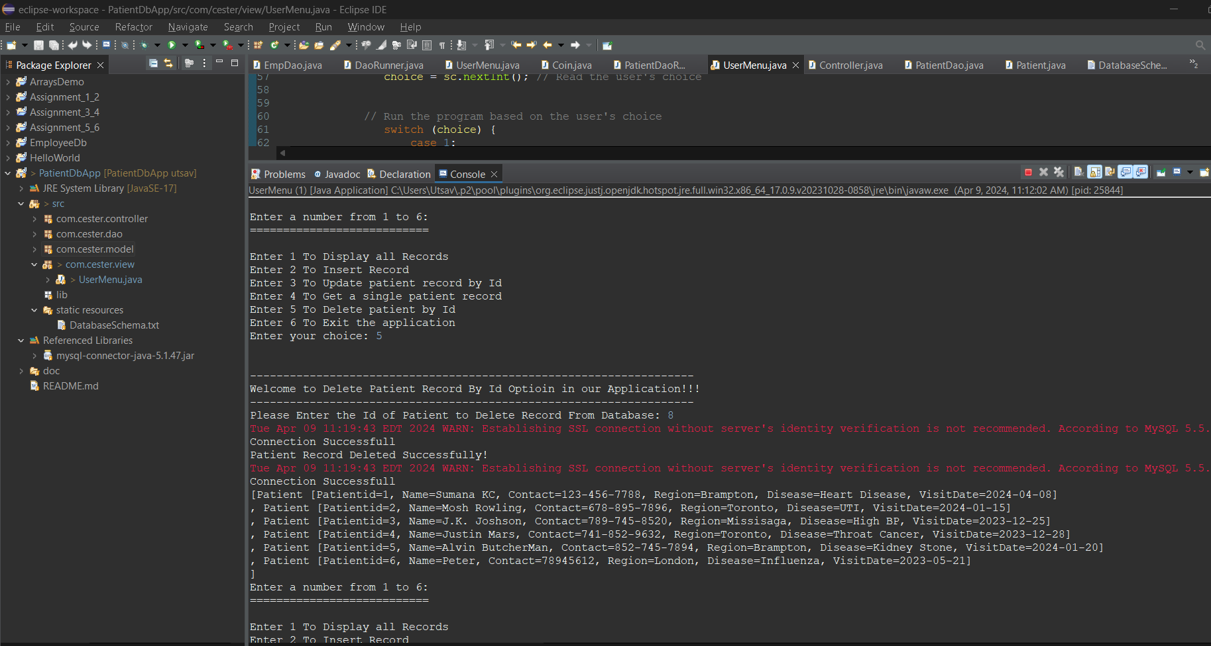

* Output in MySQL workbench

